Introduction to Databases.

DATABASE
A database is a collection of Data (Information). Examples of databases, which we use in our daily life, is an Attendance Register, Telephone Directory, Muster Rule.
Database Management System(DBMS): A database management system is a collection of programs written to manage a database. That is, it acts as a interface between user and database.

RDBMS
A Database Management System based on Relational Data Model is known as Relational Database Management System (RDBMS).
Relational Data Model was developed by Dr. E.F. CODD. He developed the relational data model by taking the concept from Relational Algebra in June - 1970.
Relational Data Model has some 12 Rules which are named after Codd as Codd Rules. According to Codd a package can be called as RDBMS only if it satisfies the Codd Rules.

ORACLE
Oracle is an Object-Relational Database Management System. It is the leading RDBMS vendor worldwide. Nearly half of RDBMS worldwide market is owned by Oracle.

ORACLE DATABASE
Every Oracle Database Contains Logical and Physical Structures. Logical Structures are tablespaces, Schema objects, extents and segments. Physical Structures are Datafiles, Redo Log Files, Control File.
A database is divided into logical storage units called tablespaces, which group related logical structures together. Each Tablespace in turn consists of one are more datafiles.
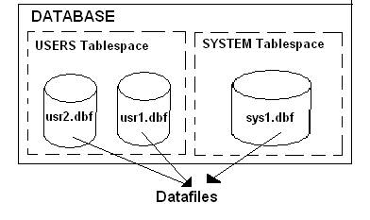
In relational database system all the information is stored in form of tables. A table consists of rows and columns
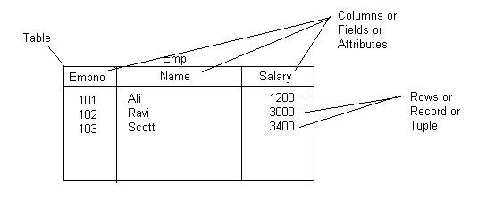
All the tables and other objects in Oracle are stored in tablespace logically, but physically they are stored in the datafiles associated with the tablespace.
Every Oracle database has a set of two or more redo log files. The set of redo log files for a database is collectively known as the database's redo log. A redo log is made up of redo entries (also called redo records).
The primary function of the redo log is to record all changes made to data. If a failure prevents modified data from being permanently written to the datafiles, the changes can be obtained from the redo log so work is never lost.
Every Oracle database has a control file. A control file contains the database name and locations of all datafiles and redo log files.
Every Oracle database also has a Parameter File. Parameter file contains the name of the Database, Memory Settings and Location of Control file.

Formatting Output in Oracle SQL * Plus

Simple and useful hints for formatting output in SQL*Plus
While using Oracle SQL*Plus for interacting with the database you must have many times seen unstructured output for SQL queries. i.e. the output is hard to interpret.
Like for example if you give a query like this
SQL> select * from all_users;
You will get a output like this
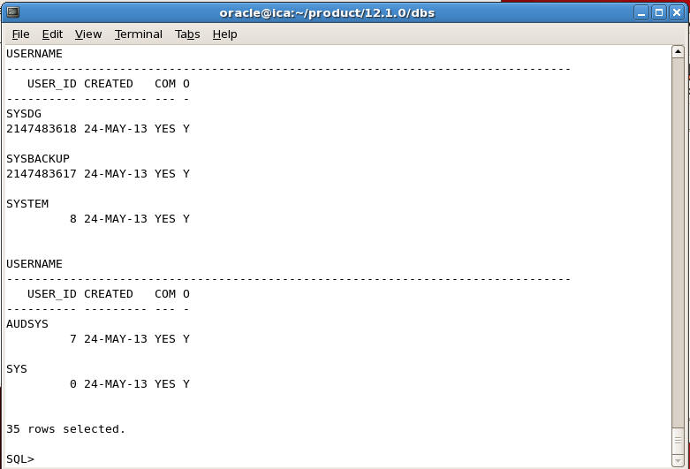
You can easily structured the output by adjusting the line size and formatting the column by typing the following commands
SQL> set linesize 100
SQL> col username format a30
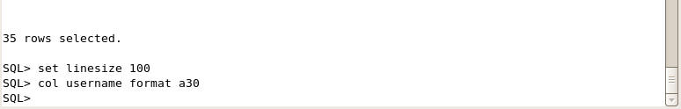
And then again give the same query, you will see the output in well structured format as shown below
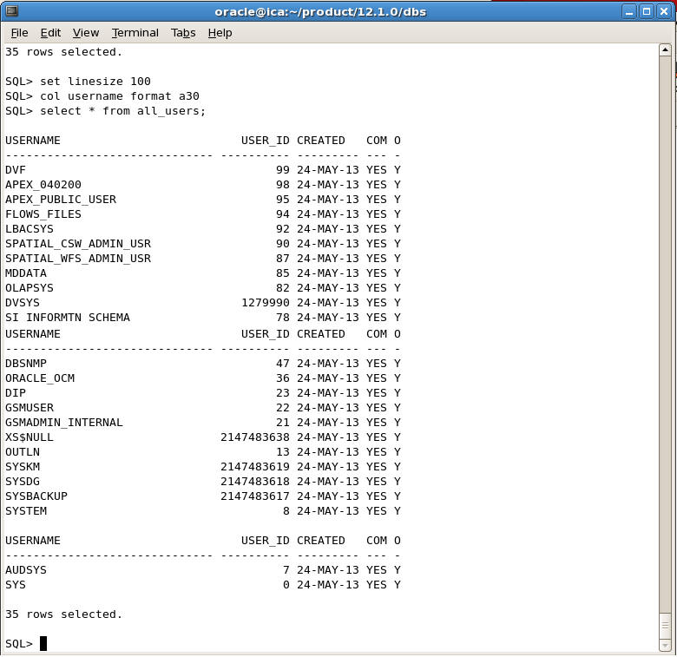

Formatting Number Values in SQL Plus
You can also set Number format so see the numeric values with commas for easy reading.
For example if you select the rows from scott emp table you will see the output like this
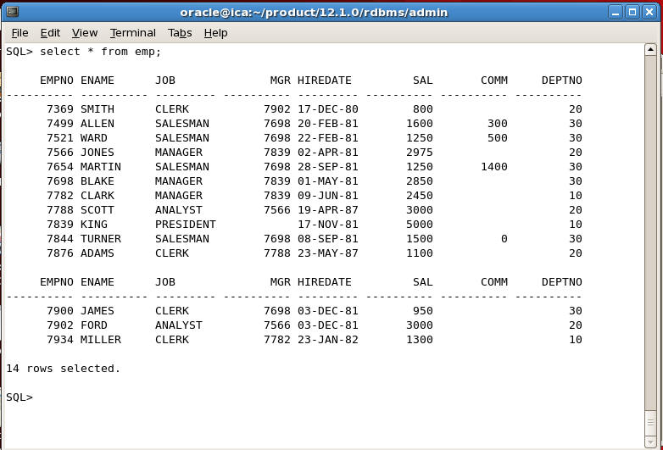
In the above output the salary column is shown without any formatting which is the default in SQL Plus. If you want to format numeric column values with commas, you can format it like this for example
SQL> col sal format $999,99,999.99
and now you will get the output like this
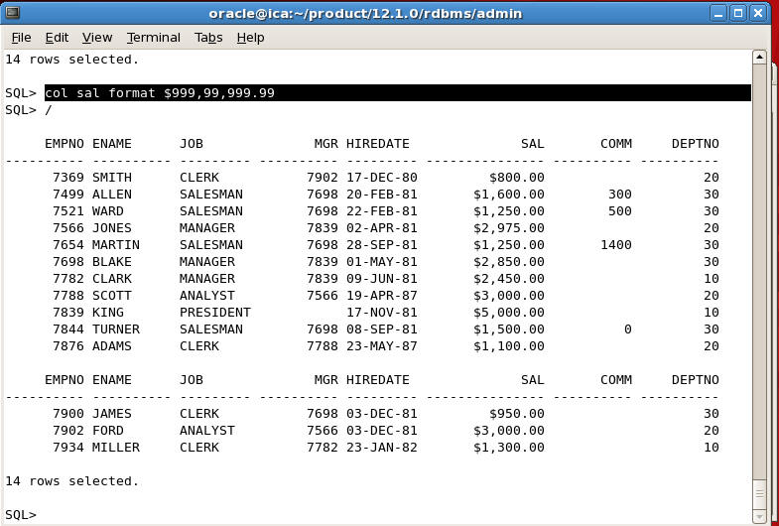
Similarly you can also format all numeric values by giving the following command
SQL> set numformat "999,99,999.99"
Remember the above command will format all numeric values i.e. even empno, deptno etc will be shown in the format, which you don't want in most case.

Format DATES in SQL Plus
Similarly you can also format date values in whatever date format you want by setting the session variable NLS_DATE_FORMAT
For example if you set it to the following
SQL> alter session set nls_date_format='dd-Mon-yyyy hh:mi:sspm';
You will get the output like this
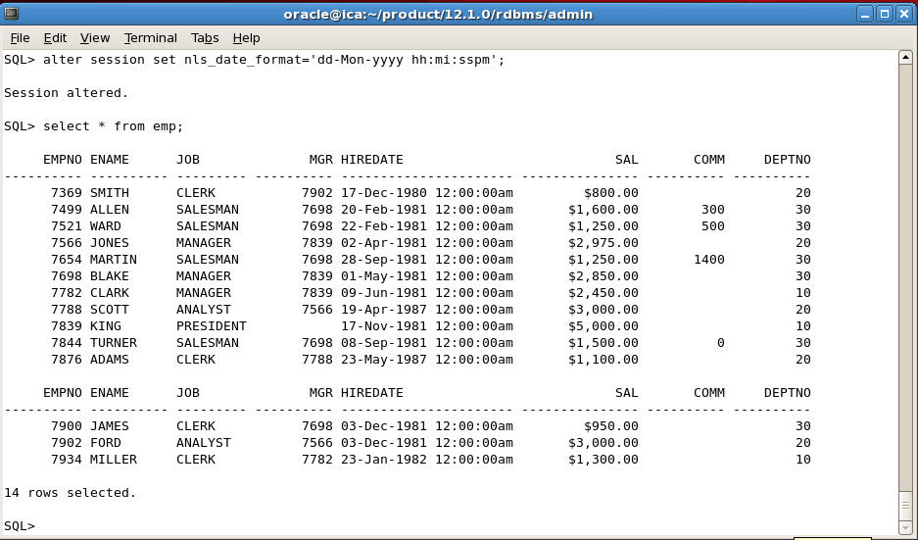

Changing SQL Prompt in SQL PLus
You can change the default SQL> prompt in SQL Plus to something more meaningful like you can show username and SID and date in the prompt by giving the following command
SQL> set sqlprompt "_user 'ON' _connect_identifier':'_date> "
Then SQL Prompt will change to the following
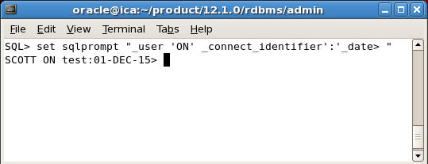
This is particularly useful if you work on multiple databases.

Automatic Setting
What about automatically setting the above formats whenever you login to SQL Plus?
If you want specific settings to be set whenever you login to SQL Plus, then you can write these set commands in glogin.sql or login.sql file located in ORACLE_HOME/sqlplus/admin folder
For example, you can open or create a new glogin.sql or login.sql file using any text editor and write the following commands
alter session set nls_date_format='dd-Mon-yyyy hh:mi:sspm';
set sqlprompt "_user 'ON' _connect_identifier':'_date> "
Now whenever you login to Oracle using SQL Plus , SQL Plus will show the dates in the above format and SQL Prompt will also change to the above format.

Data Manipulation Language (DML) Statements
Data manipulation language (DML) statements query and manipulate data in existing schema objects. These statements do not implicitly commit the current transaction.
The following are the DML statements available in Oracle.
- INSERT :Use to Add Rows to existing table.
- UPDATE :Use to Edit Existing Rows in tables.
- DELETE :Use to Delete Rows from tables.
- MERGE :Use to Update or Insert Rows depending on condition.

Insert
Use the Insert Statement to Add records to existing Tables.
Examples.
To add a new row to an emp table.
Insert into emp values (101,’Sami’,’G.Manager’,
’8-aug-1998’,2000);
If you want to add a new row by supplying values for some columns not all the columns then you have to mention the name of the columns in insert statements. For example the following statement inserts row in emp table by supplying values for empno, ename, and sal columns only. The Job and Hiredate columns will be null.
Insert into emp (empno,ename,sal) values (102,’Ashi’,5000);
Suppose you want to add rows from one table to another i.e. suppose we have Old_Emp table and emp table with the following structure
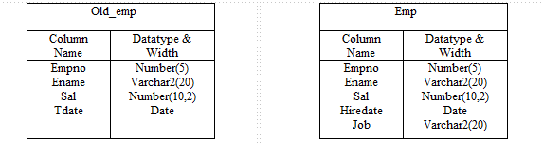
Now we want to add rows from old_emp table to emp table. Then you can give the following insert statement
Insert into emp (empno, ename, sal)
select empno, ename, sal from old_emp;

Multitable Insert
Suppose we have sales table with the following structure.
Sales
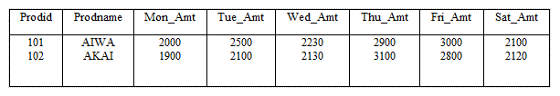
Now we want to add the rows from SALES table Weekly_Sales Table in the following Structure.
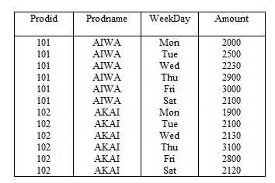
To achieve the above we can give a multi table INSERT statement given below
Insert all
Into week_sales(prodid,prodname,weekday,amount)
Values (prodid,prodname,’Mon’,mon_amt)
Into week_sales(prodid,prodname,weekday,amount)
Values (prodid,prodname,’Tue’,tue_amt)
Into week_sales(prodid,prodname,weekday,amount)
Values (prodid,prodname,’Wed’,wed_amt)
Into week_sales(prodid,prodname,weekday,amount)
Values (prodid,prodname,’Thu’,thu_amt)
Into week_sales(prodid,prodname,weekday,amount)
Values (prodid,prodname,’Fri’,fri_amt)
Into week_sales(prodid,prodname,weekday,amount)
Values (prodid,prodname,’Sat’,sat_amt)
Select prodid,prodname,mon_amt,tue_amt,wed_amt,thu_amt
Fri_amt,sat_amt from sales;

Update
Update statement is used to update rows in existing tables which is in your own schema or if you have update privilege on them.
For example to raise the salary by Rs.500 of employee number 104. You can give the following statement.
update emp set sal=sal+500 where empno = 104;
In the above statement if we did not give the where condition then all employees salary will be raised by Rs. 500. That’s why always specify proper WHERE condition if don’t want to update all employees.
For example We want to change the name of employee no 102 from ‘Sami’ to ‘Mohd Sami’ and to raise the salary by 10%. Then the statement will be.
update emp set name=’Mohd Sami’,
sal=sal+(sal*10/100) where empno=102;
Now we want to raise the salary of all employees by 5%.
update emp set sal=sal+(sal*5/100);
Now to change the names of all employees to uppercase.
update emp set name=upper(name);
Suppose We have a student table with the following structure.
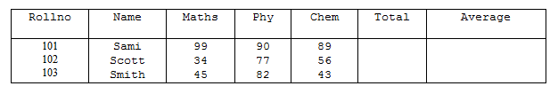
Now to compute total which is sum of Maths,Phy and Chem and average.
update student set total=maths+phy+chem,
average=(maths+phy+chem)/3;
Using Sub Query in the Update Set Clause.
Suppose we added the city column in the employee table and now we want to set this column with corresponding city column in department table which is join to employee table on deptno.
update emp set city=(select city from dept
where deptno= emp.deptno);

Delete
Use the DELETE statement to delete the rows from existing tables which are in your schema or if you have DELETE privilege on them.
For example to delete the employee whose empno is 102.
delete from emp where empno=102;
If you don’t mention the WHERE condition then all rows will be deleted.
Suppose we want to delete all employees whose salary is above 2000. Then give the following DELETE statement.
delete from emp where salary > 2000;
The following statement has the same effect as the preceding example, but uses a subquery:
DELETE FROM (SELECT * FROM emp)
WHERE sal > 2000;
To delete all rows from emp table.
delete from emp;

Merge
Use the MERGE statement to select rows from one table for update or insertion into another table. The decision whether to update or insert into the target table is based on a condition in the ON clause. It is a new feature of Oracle Ver. 9i. It is also known as UPSERT i.e. combination of UPDATE and INSERT.
For example suppose we are having sales and sales_history table with the following structure.
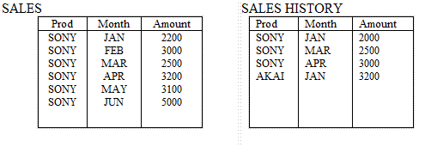

Now we want to update sales_history table from sales table i.e. those rows which are already present in sales_history, their amount should be updated and those rows which are not present in sales_history table should be inserted.
merge into sales_history sh
using sales s
on (s.prod=sh.prod and s.month=sh.month)
when matched then update set sh.amount=s.amount
when not matched then insert values (prod,month,amount);
After the statement is executed sales_history table will look like this.
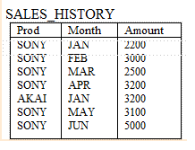

Data Definition Language (DDL) Statements
Data definition language (DDL) statements enable you to perform these tasks:
- Create, alter, and drop schema objects
- Grant and revoke privileges and roles
- Analyze information on a table, index, or cluster
- Establish auditing options
- Add comments to the data dictionary
The CREATE, ALTER, and DROP commands require exclusive access to the specified object. For example, an ALTER TABLE statement fails if another user has an open transaction on the specified table.
The GRANT, REVOKE, ANALYZE, AUDIT, and COMMENT commands do not require exclusive access to the specified object. For example, you can analyze a table while other users are updating the table.
Oracle implicitly commits the current transaction before and after every DDL statement.
Many DDL statements may cause Oracle to recompile or reauthorize schema objects.
DDL Statements are
CREATE :Use to create objects like CREATE TABLE, CREATE FUNCTION,
CREATE SYNONYM, CREATE VIEW. Etc.
ALTER :Use to Alter Objects like ALTER TABLE, ALTER USER, ALTER
TABLESPACE, ALTER DATABASE. Etc.
DROP :Use to Drop Objects like DROP TABLE, DROP USER, DROP
TABLESPACE, DROP FUNCTION. Etc.
REPLACE :Use to Rename table names.
TRUNCATE :Use to truncate (delete all rows) a table.

Create
To create tables, views, synonyms, sequences, functions, procedures, packages etc.
Example
To create a table, you can give the following statement
create table emp (empno number(5) primary key,
name varchar2(20),
sal number(10,2),
job varchar2(20),
mgr number(5),
Hiredate date,
comm number(10,2));
Now Suppose you have emp table now you want to create a TAX table with the following structure and also insert rows of those employees whose salary is above 5000.
Tax
Empno  Tax | Number(5)  Number(10,2)
To do this we can first create TAX table by defining column names and datatypes and then use INSERT into EMP SELECT …. statement to insert rows from emp table. like given below.
create table tax (empno number(5), tax number(10,2));
insert into tax select empno,(sal-5000)*0.40
from emp where sal > 5000;
Instead of executing the above two statements the same result can be achieved by giving a single CREATE TABLE AS statement.
create table tax as select empno,(sal-5000)*0.4
as tax from emp where sal>5000
You can also use CREATE TABLE AS statement to create copies of tables. Like to create a copy EMP table as EMP2 you can give the following statement.
create table emp2 as select * from emp;
To copy tables without rows i.e. to just copy the structure give the following statement
create table emp2 as select * from emp where 1=2;

Temporary Tables (From Oracle Ver. 8i)
It is also possible to create a temporary table. The definition of a temporary table is visible to all sessions, but the data in a temporary table is visible only to the session that inserts the data into the table. You use the CREATE GLOBAL TEMPORARY TABLE statement to create a temporary table. The ON COMMIT keywords indicate if the data in the table is transaction-specific (the default) or session-specific:
- ON COMMIT DELETE ROWS specifies that the temporary table is transaction specific and Oracle truncates the table (delete all rows) after each commit.
- ON COMMIT PRESERVE ROWS specifies that the temporary table is session specific and Oracle truncates the table when you terminate the session.
This example creates a temporary table that is transaction specific:
CREATE GLOBAL TEMPORARY TABLE taxable_emp
(empno number(5),
ename varchar2(20),
sal number(10,2),
tax number(10,2))
ON COMMIT DELETE ROWS;
Indexes can also be created on temporary tables. They are also temporary and the data in the index has the same session or transaction scope as the data in the underlying table.

Alter
Use the ALTER TABLE statement to alter the structure of a table.
Examples:
To add new columns addr, city, pin, ph, fax to employee table you can give the following statement
alter table emp add (addr varchar2(20), city varchar2(20),
pin varchar2(10),ph varchar2(20));
To modify the datatype and width of a column. For example we you want to increase the length of the column ename from varchar2(20) to varchar2(30) then give the following command.
alter table emp modify (ename varchar2(30))
To decrease the width of a column the column can be decreased up to largest value it holds.
alter table emp modify (ename varchar2(15));
The above is possible only if you are using Oracle ver 8i and above. In Oracle 8.0 and 7.3 you cannot decrease the column width directly unless the column is empty.
To change the datatype the column must be empty in All Oracle Versions.

To drop columns.
From Oracle Ver. 8i you can drop columns directly it was not possible in previous versions.
For example to drop PIN, CITY columns from emp table.
alter table emp drop column (pin, city);
Remember you cannot drop the column if the table is having only one column.
If the column you want to drop is having primary key constraint on it then you have to give cascade constraint clause.
alter table emp2 drop column (empno) cascade constraints;
To drop columns in previous versions of Oracle8.0 and 7.3. and to change the column name in all Oracle versions do the following.
For example we want to drop pin and city columns and to change SAL column name to SALARY.
Step 1: Create a temporary table with desired columns using subquery.
create table temp as select empno, ename,
sal AS salary, addr, ph from emp;
Step 2: Drop the original table.
drop table emp;
Step 3: Rename the temporary table to the original table.
rename temp to emp;

Rename
Use the RENAME statement to rename a table, view, sequence, or private synonym for a table, view, or sequence.
- Oracle automatically transfers integrity constraints, indexes, and grants on the old object to the new object.
- Oracle invalidates all objects that depend on the renamed object, such as views, synonyms, and stored procedures and functions that refer to a renamed table.
Example
To rename table emp2 to employee2 you can give the following command.
rename emp2 to employee2

Drop
Use the drop statement to drop tables, functions, procedures, packages, views, synonym, sequences, tablespaces etc.
Example
The following command drops table emp2
drop table emp2;
If emp2 table is having primary key constraint, to which other tables refer to, then you have to first drop referential integrity constraint and then drop the table. Or if you want to drop table by dropping the referential constraints then give the following command
drop table emp2 cascade constraints;

Truncate
Use the Truncate statement to delete all the rows from table permanently . It is same as “DELETE FROM <table_name>” except
- Truncate does not generate any rollback data hence, it cannot be roll backed.
- If any delete triggers are defined on the table. Then the triggers are not fired
- It deallocates free extents from the table. So that the free space can be use by other tables.
Example
truncate table emp;
If you do not want free space and keep it with the table. Then specify the REUSE storage clause like this
truncate table emp reuse storage;

COALESCE
Coalesce function returns the first not null value in the expression list.
Example.
The following query returns salary+commision, if commission is null then returns salary, if salary is also null then returns 1000.
select empno,ename,salary,comm,coalesce(salary+comm,salary,1000) “Net Sal” from emp;
ENAME SALARY COMM NET SAL
----- ------ ---- -------
SMITH 1000 100 1100
SAMI 3000 3000
SCOTT 1000
RAVI 200 1000

DECODE
DECODE(expr, searchvalue1, result1,searchvalue2,result2,..., defaultvalue)
Decode functions compares an expr with search value one by one. If the expr does not match any of the search value then returns the default value. If the default value is omitted then returns null.
Example
The following query returns the department names according the deptno. If the deptno does not match any of the search value then returns “Unknown Department”
select decode(deptno,10,'Sales',20,'Accounts,30,'Production,
40,'R&D','Unknown Dept') As DeptName from emp;
DEPTNAME
----------
Sales
Accounts
Unknown Dept.
Accounts
Production
Sales
R&D
Unknown Dept.

GREATEST
GREATEST(expr1, expr2, expr3,expr4...)
Returns the greatest expr from a expr list.
Example
select greatest(10,20,50,20,30) from dual;
GREATEST
--------
50

select greatest('SAMI','SCOTT','RAVI','SMITH','TANYA') from dual;
GREATEST
--------
TANYA

LEAST
LEAST(expr1, expr2, expr3,expr4...)
It is simillar to greatest. It returns the least expr from the expression list.
select least(10,20,50,20,30) from dual;
LEAST
--------
10
select least('SAMI','SCOTT','RAVI','SMITH','TANYA') from dual;
LEAST
--------
RAVI

NVL
NVL2(expr1,expr2)
This function is oftenly used to check null values. It returns expr2 if the expr1 is null, otherwise returns expr1.
Example
The following query returns commission if commission is null then returns 'Not Applicable'.
Select ename,nvl(comm,'Not Applicable') “Comm” from dual;
ENAME COMM
------ ----
Scott 300
Tiger 450
Sami Not Applicable
Ravi 300
Tanya Not Applicable

NVL2
NVL2(expr1,expr2,expr3)
NVL2 returns expr2 if expr1 is not null, otherwise return expr3.
Example
The following query returns salary+comm if comm is not null, otherwise just returns salary.
select salary,comm,nvl2(comm,salary+comm,salary) “Income” from emp;
SALARY COMM INCOME
------ ---- ------
1000 100 1100
2000 2000
2300 200 2500
3400 3400

NULLIF
NULLIF(expr1, expr2)
Nullif compares expr1 with expr2. If they are equal then returns null, otherwise return expr1.
Example.
The following query shows old jobs of those employees who have changed their jobs in the company by comparing the current job with old job in oldemp table.
Select ename,nullif(e.job,o.job) “Old Job” from emp e, oldemp o where e.empno=o.empno;
ENAME OLD JOB
----- -------
SMITH CLERK
SAMI
SCOTT MANAGER

UID
Returns the current session ID of user logged on.
Example
select uid from dual;
UID
----
20

USER
Returns the username of the current user logged on.
select user from dual;
USER
---------
SCOTT

SYS_CONTEXT
SYS_CONTEXT returns the value of parameter associated with the context namespace. You can use this function in both SQL and PL/SQL statements.
EXAMPLE
The following query returns the username of the current user.
Select sys_context('USERENV','SESSION_USER') “Username” from dual;
USERNAME
---------
SCOTT
Similar to SESSION_USER parameter for namespace USERENV the other important parameters are
ISDBA :To check whether the current user is having DBA privileges or not.
HOST :Returns the name of host machine from which the client is connected.
INSTANCE :The instance identification number of the current instance
IP_ADDRESS: IP address of the machine from which the client is connected.
DB_NAME :Name of the database as specified in the DB_NAME initialization parameter

VSIZE
VSIZE(expr)
Returns the internal representation of expr in bytes.
Example
The following query return the representation of ename in bytes.
select ename,vsize(ename) as Bytes from emp;
ENAME BYTES
------ ------
SCOTT 5
SAMI 4
RAVI 4
KIRAN 5

Date Functions and Operators.
To see the system date and time use the following functions :
CURRENT_DATE :returns the current date in the session time zone, in a value in the Gregorian calendar of datatype
DATE
SYSDATE :Returns the current date and time.
SYSTIMESTAMP :The SYSTIMESTAMP function returns the system date, including fractional seconds and time zone
of the database. The return type is TIMESTAMP WITH TIME ZONE.

SYSDATE Example
To see the current system date and time give the following query.
select sysdate from dual;
SYSDATE
-------
8-AUG-03
The format in which the date is displayed depends on NLS_DATE_FORMAT parameter.
For example set the NLS_DATE_FORMAT to the following format
alter session set NLS_DATE_FORMAT=’DD-MON-YYYY HH:MIpm’;
Then give the give the following statement
select sysdate from dual;
SYSDATE
------------------
8-AUG-2003 03:05pm
The default setting of NLS_DATE_FORMAT is DD-MON-YY

CURRENT_DATE Example
To see the current system date and time with time zone use CURRENT_DATE function
ALTER SESSION SET TIME_ZONE = '-4:0';
ALTER SESSION SET NLS_DATE_FORMAT = 'DD-MON-YYYY HH24:MI:SS';
SELECT SESSIONTIMEZONE, CURRENT_DATE FROM DUAL;
SESSIONTIMEZONE CURRENT_DATE
--------------- --------------------
-04:00 22-APR-2003 14:15:03
ALTER SESSION SET TIME_ZONE = '-7:0';
SELECT SESSIONTIMEZONE, CURRENT_DATE FROM DUAL;
SESSIONTIMEZONE CURRENT_DATE
--------------- --------------------
-07:00 22-APR-2003 09:15:33

SYSTIMESTAMP Example
To see the current system date and time with fractional seconds with time zone give the following statement
select systimestamp from dual;
SYSTIMESTAMP
-------------------------------
22-APR-03 08.38.55.538741 AM -07:00

DATE FORMAT MODELS
To translate the date into a different format string you can use TO_CHAR function with date format. For example to see the current day you can give the following query
Select to_char(sysdate,’DAY’)”Today” FROM DUAL;
TODAY
-------
THURSDAY
To translate a character value, which is in format other than the default date format, into a date value you can use TO_DATE function with date format to date
Like this “DAY” format model there are many other date format models available in Oracle. The following table list date format models.
FORMAT | MEANING
D | Day of the week
DD | Day of the month
DDD | Day of the year
DAY | Full day for ex. ‘Monday’, ’Tuesday’, ’Wednesday’
DY | Day in three letters for ex. ‘MON’, ‘TUE’,’FRI’
W | Week of the month
WW | Week of the year
MM | Month in two digits (1-Jan, 2-Feb,…12-Dec)
MON | Month in three characters like “Jan”, ”Feb”, ”Apr”
MONTH | Full Month like “January”, ”February”, ”April”
RM | Month in Roman Characters (I-XII, I-Jan, II-Feb,…XII-Dec)
Q | Quarter of the Month
YY | Last two digits of the year.
YYYY | Full year
YEAR | Year in words like “Nineteen Ninety Nine”
HH | Hours in 12 hour format
HH12 | Hours in 12 hour format
HH24 | Hours in 24 hour format
MI | Minutes
SS | Seconds
FF | Fractional Seconds
SSSSS | Milliseconds
J | Julian Day i.e Days since 1st-Jan-4712BC to till-date
RR | If the year is less than 50 Assumes the year as 21ST Century. If the year is greater than 50 then assumes the year in 20th Century.

suffixes
TH | Returns th, st, rd or nd according to the leading number like 1st , 2nd 3rd 4th
SP | Spells out the leading number
AM or PM | Returns AM or PM according to the time
SPTH | Returns Spelled Ordinal number. For. Example First, Fourth
For example to see the today’s date in the following format
Friday, 7th March, 2014
Give the following statement
select to_char(sysdate,’Day, ddth Month, yyyy’)”Today” from dual;
TODAY
------------------------
Friday, 7th March, 2014
For example you want to see hire dates of all employee in the following format
Friday, 8th August, 2003
Then give the following query.
select to_char(hire_date,’Day, ddth Month, yyyy’) from emp;

TO_DATE Example
To_Date function is used to convert strings into date values. For example you want to see what was the day on 15-aug-1947. The use the to_date function to first convert the string into date value and then pass on this value to to_char function to extract day.
select to_char(to_date(’15-aug-1947’,’dd-mon-yyyy’),’Day’)
from dual;
TO_CHAR(
--------
Friday
To see how many days have passed since 15-aug-1947 then give the following query
select sysdate-to_date(’15-aug-1947’,’dd-mon-yyyy’) from dual;
Now we want to see which date will occur after 45 days from now
select sysdate+45 from dual;
SYSDATE
-------
06-JUN-2003

ADD_MONTHS
To see which date will occur after 6 months from now, we can use ADD_MONTHS function
Select ADD_MONTHS(SYSDATE,6) from dual;
ADD_MONTHS
----------
22-OCT-2003

MONTHS_BETWEEN
To see how many months have passed since a particular date, use the MONTHS_BETWEEN function.
For Example, to see how many months have passed since 15-aug-1947, give the following query.
select months_between(sysdate,to_date(’15-aug-1947’))
from dual;
Months
------
616.553
To eliminate the decimal value use truncate function
select trunc(months_between(sysdate,to_date(’15-aug-1947’)))
from dual;
Months
------
616

LAST_DAY
To see the last date of the month of a given date, Use LAST_DAY function.
select LAST_DAY(sysdate) from dual;
LAST_DAY
--------
31-AUG-2003

NEXT_DAY
To see when a particular day is coming next , use the NEXT_DAY function.
For Example to view when next Saturday is coming, give the following query
select next_day(sysdate) from dual;
NEXT_DAY
-----------
09-AUG-2003

EXTRACT
An EXTRACT datetime function extracts and returns the value of a specified datetime field from a datetime or interval value expression. When you extract a TIMEZONE_REGION or TIMEZONE_ABBR (abbreviation), the value returned is a string containing the appropriate time zone name or abbreviation
The syntax of EXTRACT function is
EXTRACT ( YEAR / MONTH / WEEK / DAY / HOUR / MINUTE / TIMEZONE FROM DATE)
Example
The following demonstrate the usage of EXTRACT function to extract year from current date.
select extract(year from sysdate) from dual;
EXTRACT
-------
2003

Character Functions
Character functions operate on values of dataype CHAR or VARCHAR.

LOWER
Returns a given string in lower case.
select LOWER(‘SAMI’) from dual;
LOWER
-------------
sami

UPPER
Returns a given string in UPPER case.
select UPPER(‘Sami’) from dual;
UPPER
------------------
SAMI

INITCAP
Returns a given string with Initial letter in capital.
select INITCAP(‘mohammed sami’) from dual;
INITCAP
------------------
Mohammed Sami

LENGTH
Returns the length of a given string.
select length(‘mohammed sami’) from dual;
LENGTH
------------
13

SUBSTR
Returns a substring from a given string. Starting from position p to n characters.
For example the following query returns “sam” from the string “mohammed sami”.
select substr('mohammed sami',10,3) from dual;
Substr
--------
sam

INSTR
Tests whether a given character occurs in the given string or not. If the character occurs in the string then returns the first position of its occurrence otherwise returns 0.
Example
The following query tests whether the character “a” occurs in string “mohammed sami”
select instr('mohammed sami','a') from dual;
INSTR
--------
4

REPLACE
Replaces a given set of characters in a string with another set of characters.
Example
The following query replaces “mohd” with “mohammed” .
select replace('ali mohd khan','mohd','mohammed') from dual;
REPLACE
---------
ali mohammed khan

INSTR
Tests whether a given character occurs in the given string or not. If the character occurs in the string then returns the first position of its occurrence otherwise returns 0.
Example
The following query tests whether the character “a” occurs in string “mohammed sami”
select instr('mohammed sami','a') from dual;
INSTR
--------
4

REPLACE
Replaces a given set of characters in a string with another set of characters.
Example
The following query replaces “mohd” with “mohammed” .
select replace('ali mohd khan','mohd','mohammed') from dual;
REPLACE
---------
ali mohammed khan

TRANSLATE
This function is used to encrypt characters. For example you can use this function to replace characters in a given string with your coded characters.
Example
The following query replaces characters A with B, B with C, C with D, D with E,...Z with A, and a with b,b with c,c with d, d with e ....z with a.
select translate('interface','ABCDEFGHIJKLMNOPQRSTUVWXYZabcdefghijklmnopqrstuvwxyz',
'BCDEFGHIJKLMNOPQRSTUVWXYZAbcdefghijklmnopqrstuvwxyza') “Encrypt” from dual;
Encrypt
-----------
joufsgbdf

SOUNDEX
This function is used to check pronounciation rather than exact characters. For example many people write names as “smith” or “smyth” or “smythe” but they are pronounced as smith only.
Example
The following example compare those names which are spelled differently but are pronouced as “smith”.
Select ename from emp where soundex(ename)=soundex('smith');
ENAME
---------
Smith
Smyth
Smythe

RPAD
Right pads a given string with a given character to n number of characters.
Example
The following query rights pad ename with '*' until it becomes 10 characters.
select rpad(ename,'*',10) from emp;
Ename
----------
Smith*****
John******
Mohammed**
Sami******

LPAD
Left pads a given string with a given character upto n number of characters.
Example
The following query left pads ename with '*' until it becomes 10 characters.
select lpad(ename,'*',10) from emp;
Ename
----------
*****Smith
******John
**Mohammed
******Sami

LTRIM
Trims blank spaces from a given string from left.
Example
The following query returns string “ Interface “ left trimmed.
select ltrim(' Interface ') from dual;
Ltrim
--------------
Interface

RTRIM
Trims blank spaces from a given string from Right.
Example
The following query returns string “ Interface “ right trimmed.
select rtrim(' Interface ') from dual;
Rtrim
------------
Interface

TRIM
Trims a given character from left or right or both from a given string.
Example
The following query removes zero from left and right of a given string.
Select trim(0 from '00003443500') from dual;
Trim
----------
34435

CONCAT
Combines a given string with another string.
Example
The following Query combines ename with literal string “ is a “ and jobid.
Select concat(concat(ename,' is a '),job) from emp;
Concat
----------------
Smith is a clerk
John is a Manager
Sami is a G.Manager

Number Functions (also known as Math Functions)
Number functions accept numeric input and return numeric values. Most of these functions return values that are accurate to 38 decimal digits.
The number functions available in Oracle are:
ABS ACOS ASIN ATAN ATAN2 BITAND CEIL COS COSH EXP FLOOR LN LOG
MOD POWER ROUND (number) SIGN SIN SINH SQRT TAN TANH TRUNC (number)

ABS
ABS returns the absolute value of n.
The following example returns the absolute value of -87:
SELECT ABS(-87) "Absolute" FROM DUAL;
Absolute
----------
87

ACOS
ACOS returns the arc cosine of n. Inputs are in the range of -1 to 1, and outputs are in the range of 0 to pi and are expressed in radians.
The following example returns the arc cosine of .3:
SELECT ACOS(.3)"Arc_Cosine" FROM DUAL;
Arc_Cosine
----------
1.26610367
Similar to ACOS, you have ASIN (Arc Sine), ATAN (Arc Tangent) functions.

CIEL
Returns the lowest integer above the given number.
Example:
The following function return the lowest integer above 3.456;
select ciel(3.456) “Ciel” from dual;
Ciel
---------
4

FLOOR
Returns the highest integer below the given number.
Example:
The following function return the highest integer below 3.456;
select floor(3.456) “Floor” from dual;
Floor
------------
3

COS
Returns the cosine of an angle (in radians).
Example:
The following example returns the COSINE angle of 60 radians.
select cos(60) “Cosine” from dual;

SIN
Returns the Sine of an angle (in radians).
Example:
The following example returns the SINE angle of 60 radians.
select SIN(60) “Sine” from dual;

TAN
Returns the Tangent of an angle (in radians).
Example:
The following example returns the tangent angle of 60 radians.
select Tan(60) “Tangent” from dual;
Similar to SIN, COS, TAN functions hyperbolic functions SINH, COSH, TANH are also available in oracle.

MOD
Returns the remainder after dividing m with n.
Example
The following example returns the remainder after dividing 30 by 4.
Select mod(30,4) “MOD” from dual;
MOD
---------
2

POWER
Returns the power of m, raised to n.
Example
The following example returns the 2 raised to the power of 3.
select power(2,3) “Power” from dual;
POWER
---------
8

EXP
Returns the e raised to the power of n.
Example
The following example returns the e raised to power of 2.
select exp(2) “e raised to 2” from dual;
E RAISED TO 2
-------------

LN
Returns natural logarithm of n.
Example
The following example returns the natural logarithm of 2.
select ln(2) from dual;
LN
------------

LOG
Returns the logarithm, base m, of n.
Example
The following example returns the log of 100.
select log(10,100) from dual;
LOG
---------
2

ROUND
Returns a decimal number rounded of to a given decimal positions.
Example
The following example returns the no. 3.4573 rounded to 2 decimals.
select round(3.4573,2) “Round” from dual;
Round
------------
3.46

TRUNC
Returns a decimal number Truncated to a given decimal positions.
Example
The following example returns the no. 3.4573 truncated to 2 decimals.
select round(3.4573,2) “Round” from dual;
Round
------------
3.45

SQRT
Returns the square root of a given number.
Example
The following example returns the square root of 16.
select sqrt(16) from dual;
SQRT
---------
4

Aggregate Functions
Aggregate functions return a single value based on groups of rows, rather than single value for each row. You can use Aggregate functions in select lists and in ORDER BY and HAVING clauses. They are commonly used with the GROUP BY clause in a SELECT statement, where Oracle divides the rows of a queried table or view into groups.
The important Aggregate functions are :
Avg Sum Max Min Count Stddev Variance

AVG
AVG( ALL /DISTINCT expr)
Returns the average value of expr.
Example
The following query returns the average salary of all employees.
select avg(sal) “Average Salary” from emp;
Average Salary
------------------------
2400.40

SUM
SUM(ALL/DISTINCT expr)
Returns the sum value of expr.
Example
The following query returns the sum salary of all employees.
select sum(sal) “Total Salary” from emp;
Total Salary
------------------------
26500

MAX
MAX(ALL/DISTINCT expr)
Returns maximum value of expr.
Example
The following query returns the max salary from the employees.
select max(sal) “Max Salary” from emp;
Maximum Salary
------------------------
4500

MIN
MIN(ALL/DISTINCT expr)
Returns minimum value of expr.
Example
The following query returns the minimum salary from the employees.
select min(sal) “Min Salary” from emp;
Minimum Salary
------------------------
1200

COUNT
COUNT(*) OR COUNT(ALL/DISTINCT expr)
Returns the number of rows in the query. If you specify expr then count ignore nulls. If you specify the asterisk (*), this function returns all rows, including duplicates and nulls. COUNT never returns null.
Example
The following query returns the number of employees.
Select count(*) from emp;
COUNT
------
14
The following query counts the number of employees whose salary is not null.
Select count(sal) from emp;
COUNT
------
12

STDDEV
STDDEV(ALL/DISTINCT expr)
STDDEV returns sample standard deviation of expr, a set of numbers.
Example
The following query returns the standard deviation of salaries.
select stddev(sal) from emp;
Stddev
-------
1430

VARIANCE
VARIANCE(ALL/DISTINCT expr)
Variance returns the variance of expr.
Example
The following query returns the variance of salaries.
select variance(sal) from emp;
Variance
-------
1430

Date Functions and Operators.
To see the system date and time use the following functions :
CURRENT_DATE :returns the current date in the session time zone, in a value in the Gregorian calendar of datatype
DATE
SYSDATE :Returns the current date and time.
SYSTIMESTAMP :The SYSTIMESTAMP function returns the system date, including fractional seconds and time zone
of the database. The return type is TIMESTAMP WITH TIME ZONE.

SYSDATE Example
To see the current system date and time give the following query.
select sysdate from dual;
SYSDATE
-------
8-AUG-03
The format in which the date is displayed depends on NLS_DATE_FORMAT parameter.
For example set the NLS_DATE_FORMAT to the following format
alter session set NLS_DATE_FORMAT=’DD-MON-YYYY HH:MIpm’;
Then give the give the following statement
select sysdate from dual;
SYSDATE
------------------
8-AUG-2003 03:05pm
The default setting of NLS_DATE_FORMAT is DD-MON-YY

CURRENT_DATE Example
To see the current system date and time with time zone use CURRENT_DATE function
ALTER SESSION SET TIME_ZONE = '-4:0';
ALTER SESSION SET NLS_DATE_FORMAT = 'DD-MON-YYYY HH24:MI:SS';
SELECT SESSIONTIMEZONE, CURRENT_DATE FROM DUAL;
SESSIONTIMEZONE CURRENT_DATE
--------------- --------------------
-04:00 22-APR-2003 14:15:03
ALTER SESSION SET TIME_ZONE = '-7:0';
SELECT SESSIONTIMEZONE, CURRENT_DATE FROM DUAL;
SESSIONTIMEZONE CURRENT_DATE
--------------- --------------------
-07:00 22-APR-2003 09:15:33

SYSTIMESTAMP Example
To see the current system date and time with fractional seconds with time zone give the following statement
select systimestamp from dual;
SYSTIMESTAMP
-------------------------------
22-APR-03 08.38.55.538741 AM -07:00

DATE FORMAT MODELS
To translate the date into a different format string you can use TO_CHAR function with date format. For example to see the current day you can give the following query
Select to_char(sysdate,’DAY’)”Today” FROM DUAL;
TODAY
-------
THURSDAY
To translate a character value, which is in format other than the default date format, into a date value you can use TO_DATE function with date format to date
Like this “DAY” format model there are many other date format models available in Oracle. The following table list date format models.
FORMAT | MEANING
D | Day of the week
DD | Day of the month
DDD | Day of the year
DAY | Full day for ex. ‘Monday’, ’Tuesday’, ’Wednesday’
DY | Day in three letters for ex. ‘MON’, ‘TUE’,’FRI’
W | Week of the month
WW | Week of the year
MM | Month in two digits (1-Jan, 2-Feb,…12-Dec)
MON | Month in three characters like “Jan”, ”Feb”, ”Apr”
MONTH | Full Month like “January”, ”February”, ”April”
RM | Month in Roman Characters (I-XII, I-Jan, II-Feb,…XII-Dec)
Q | Quarter of the Month
YY | Last two digits of the year.
YYYY | Full year
YEAR | Year in words like “Nineteen Ninety Nine”
HH | Hours in 12 hour format
HH12 | Hours in 12 hour format
HH24 | Hours in 24 hour format
MI | Minutes
SS | Seconds
FF | Fractional Seconds
SSSSS | Milliseconds
J | Julian Day i.e Days since 1st-Jan-4712BC to till-date
RR | If the year is less than 50 Assumes the year as 21ST Century. If the year is greater than 50 then assumes the year in 20th Century.

suffixes
TH | Returns th, st, rd or nd according to the leading number like 1st , 2nd 3rd 4th
SP | Spells out the leading number
AM or PM | Returns AM or PM according to the time
SPTH | Returns Spelled Ordinal number. For. Example First, Fourth
For example to see the today’s date in the following format
Friday, 7th March, 2014
Give the following statement
select to_char(sysdate,’Day, ddth Month, yyyy’)”Today” from dual;
TODAY
------------------------
Friday, 7th March, 2014
For example you want to see hire dates of all employee in the following format
Friday, 8th August, 2003
Then give the following query.
select to_char(hire_date,’Day, ddth Month, yyyy’) from emp;

TO_DATE Example
To_Date function is used to convert strings into date values. For example you want to see what was the day on 15-aug-1947. The use the to_date function to first convert the string into date value and then pass on this value to to_char function to extract day.
select to_char(to_date(’15-aug-1947’,’dd-mon-yyyy’),’Day’)
from dual;
TO_CHAR(
--------
Friday
To see how many days have passed since 15-aug-1947 then give the following query
select sysdate-to_date(’15-aug-1947’,’dd-mon-yyyy’) from dual;
Now we want to see which date will occur after 45 days from now
select sysdate+45 from dual;
SYSDATE
-------
06-JUN-2003

ADD_MONTHS
To see which date will occur after 6 months from now, we can use ADD_MONTHS function
Select ADD_MONTHS(SYSDATE,6) from dual;
ADD_MONTHS
----------
22-OCT-2003

MONTHS_BETWEEN
To see how many months have passed since a particular date, use the MONTHS_BETWEEN function.
For Example, to see how many months have passed since 15-aug-1947, give the following query.
select months_between(sysdate,to_date(’15-aug-1947’))
from dual;
Months
------
616.553
To eliminate the decimal value use truncate function
select trunc(months_between(sysdate,to_date(’15-aug-1947’)))
from dual;
Months
------
616

LAST_DAY
To see the last date of the month of a given date, Use LAST_DAY function.
select LAST_DAY(sysdate) from dual;
LAST_DAY
--------
31-AUG-2003

NEXT_DAY
To see when a particular day is coming next , use the NEXT_DAY function.
For Example to view when next Saturday is coming, give the following query
select next_day(sysdate) from dual;
NEXT_DAY
-----------
09-AUG-2003

EXTRACT
An EXTRACT datetime function extracts and returns the value of a specified datetime field from a datetime or interval value expression. When you extract a TIMEZONE_REGION or TIMEZONE_ABBR (abbreviation), the value returned is a string containing the appropriate time zone name or abbreviation
The syntax of EXTRACT function is
EXTRACT ( YEAR / MONTH / WEEK / DAY / HOUR / MINUTE / TIMEZONE FROM DATE)
Example
The following demonstrate the usage of EXTRACT function to extract year from current date.
select extract(year from sysdate) from dual;
EXTRACT
-------
2003
Sub Queries and GROUP BY Queries in Oracle

SUBQUERIES
A query nested within a query is known as subquery.
For example, you want to see all the employees whose salary is above average salary. For this you have to first compute the average salary using AVG function and then compare employees salaries with this computed salary. This is possible using subquery. Here the sub query will first compute the average salary and then main query will execute.
Select * from emp where sal > (select avg(sal) from emp);
Similarly we want to see the name and empno of that employee whose salary is maximum.
Select * from emp where sal = (select max(sal) from emp);
To see second maximum salary
Select max(sal) from emp where
sal < (select max(sal) from emp);
Similarly to see the Third highest salary.
Select max(sal) from emp where
sal < (select max(sal) from emp where
sal < (select max(sal) from emp));
We want to see how many employees are there whose salary is above average.
Select count(*) from emp where
sal > (select max(sal) from emp);
We want to see those employees who are working in Hyderabad. Remember emp and dept are joined on deptno and city column is in the dept table. Assuming that wherever the department is located the employee is working in that city.
Select * from emp where deptno
in (select deptno from dept where city=’HYD’);
You can also use subquery in FROM clause of SELECT statement.
For example the following query returns the top 5 salaries from employees table.
Select sal from (select sal from emp order sal desc)
where rownum <= 5;
To see the sum salary deptwise you can give the following query.
Select sum(sal) from emp group by deptno;
Now to see the average total salary deptwise you can give a sub query in FROM clause.
select avg(depttotal) from (select sum(sal) as depttotal from emp group by deptno);

WITH
The above average total salary department wise can also be achieved from Oracle Version 9i using WITH clause given below
WITH
DEPTOT AS (select sum(sal) as dsal from emp
group by deptno)
select avg(dsal) from deptot;

GROUP BY QUERIES
You can group query results on some column values. When you give a SELECT statement without group by clause then all the resultant rows are treated as a single group.
For Example, we want to see the sum salary of all employees dept wise. Then the following query will achieved the result
Select deptno,sum(sal) from emp group by deptno;
Similarly we want to see the average salary dept wise
Select deptno,avg(sal) from emp group by deptno;
Similarly we want to see the maximum salary in each department.
Select deptno,max(sal) from emp group by deptno;
Similarly the minimum salary.
Select deptno,min(sal) from emp group by deptno;
Now we want to see the number of employees working in each department.
Select deptno,count(*) from emp group by deptno;
Now we want to see total salary department wise where the dept wise total salary is above 5000.
For this you have to use HAVING clause. Remember HAVING clause is used to filter groups and WHERE clause is used to filter rows. You cannot use WHERE clause to filter groups.
select deptno,sum(sal) from emp group by deptno
having sum(sal) >= 5000;
We want to see those departments and the number of employees working in them where the number of employees is more than 2.
Select deptno, count(*) from emp group by deptno
having count(*) >=2;
Instead of displaying deptno you can also display deptnames by using join conditions.
For example we want to see deptname and average salary of them.
Select dname,avg(sal) from emp,dept
where emp.deptno=dept.deptno group by dname;
Similarly to see sum of sal.
Select dname,sum(sal) from emp,dept
where emp.deptno=dept.deptno group by dname;
We want to see the cities name and the no of employees working in each city. Remember emp and dept are joined on deptno and city column is in the dept table. Assuming that wherever the department is located the employee is working in that city.
Select dept.city,count(empno) from emp,dept
where emp.deptno=dept.deptno
Group by dept.city;
Join Queries in Oracle

Joins
A join is a query that combines rows from two or more tables, views, or materialized views. Oracle performs a join whenever multiple tables appear in the query's FROM clause. The query's select list can select any columns from any of these tables. If any two of these tables have a column name in common, you must qualify all references to these columns throughout the query with table names to avoid ambiguity.

Join Conditions
Most join queries contain WHERE clause conditions that compare two columns, each from a different table. Such a condition is called a join condition. To execute a join, Oracle combines pairs of rows, each containing one row from each table, for which the join condition evaluates to TRUE. The columns in the join conditions need not also appear in the select list.

Equijoins
An equijoin is a join with a join condition containing an equality operator ( = ). An equijoin combines rows that have equivalent values for the specified columns.
For example the following query returns empno,name,sal,deptno and department name and city from department table.
select emp.empno,emp.ename,emp.sal,emp.deptno,dept.dname,dept.city from emp,dept where emp.deptno=dept.deptno;
The above query can also be written like, using aliases, given below.
select e.empno, e.ename, e.sal, e.deptno, d.dname, d.city from emp e, dept d where emp.deptno=dept.deptno;
The above query can also be written like given below without using table qualifiers.
select empno,ename,sal,dname,city from emp,dept where emp.deptno=dept.deptno;
And if you want to see all the columns of both tables then the query can be written like this.
select * from emp,dept where emp.deptno=dept.deptno;

Non Equi Joins.
Non equi joins is used to return result from two or more tables where exact join is not possible.
For example we have emp table and salgrade table. The salgrade table contains grade and their low salary and high salary. Suppose you want to find the grade of employees based on their salaries then you can use NON EQUI join.
select e.empno, e.ename, e.sal, s.grade from emp e, salgrade s
where e.sal between s.lowsal and s.hisal

Self Joins
A self join is a join of a table to itself. This table appears twice in the FROM clause and is followed by table aliases that qualify column names in the join condition. To perform a self join, Oracle combines and returns rows of the table that satisfy the join condition.
For example the following query returns employee names and their manager names for whom they are working.
Select e.empno, e.ename, m.ename “Manager” from emp e,
emp m where e.mgrid=m.empno

Inner Join
An inner join (sometimes called a "simple join") is a join of two or more tables that returns only those rows that satisfy the join condition.

Outer Joins
An outer join extends the result of a simple join. An outer join returns all rows that satisfy the join condition and also returns some or all of those rows from one table for which no rows from the other satisfy the join condition.
- To write a query that performs an outer join of tables A and B and returns all rows from A (a left outer join), use the ANSI LEFT [OUTER] JOIN syntax, or apply the outer join operator (+) to all columns of B in the join condition. For all rows in A that have no matching rows in B, Oracle returns null for any select list expressions containing columns of B.
- To write a query that performs an outer join of tables A and B and returns all rows from B (a right outer join), use the ANSI RIGHT [OUTER] syntax, or apply the outer join operator (+) to all columns of A in the join condition. For all rows in B that have no matching rows in A, Oracle returns null for any select list expressions containing columns of A.
- To write a query that performs an outer join and and returns all rows from A and B, extended with nulls if they do not satisfy the join condition (a full outer join), use the ANSI FULL [OUTER] JOIN syntax.
For example the following query returns all the employees and department names and even those department names where no employee is working.
select e.empno,e.ename,e.sal,e.deptno,d.dname,d.city from emp e, dept d
where e.deptno(+)=d.deptno;
That is specify the (+) sign to the column which is lacking values.

Cartesian Products
If two tables in a join query have no join condition, Oracle returns their Cartesian product. Oracle combines each row of one table with each row of the other. A Cartesian product always generates many rows and is rarely useful. For example, the Cartesian product of two tables, each with 100 rows, has 10,000 rows. Always include a join condition unless you specifically need a Cartesian product.

The UNION [ALL], INTERSECT, MINUS Operators
You can combine multiple queries using the set operators UNION, UNION ALL, INTERSECT, and MINUS. All set operators have equal precedence. If a SQL statement contains multiple set operators, Oracle evaluates them from the left to right if no parentheses explicitly specify another order.

UNION Example
The following statement combines the results with the UNION operator, which eliminates duplicate selected rows.
select empno,ename,sal from emp
UNION
select empno,ename,salary from oldemp
What if you need to select rows from two tables, but tables have different columns?
In this situation you have to use TO_CHAR function to fill up missing columns.
For Example
This statement shows that you must match datatype (using the TO_CHAR function) when columns do not exist in one or the other table:
select empno, ename, sal, to_char(null) as “Transfer Date” from emp
UNION
select empno,ename,to_char(null) as “Sal”,tdate from oldemp;
EMPNO ENAME SAL Transfer Date
----- ----- ------ -------------
101 Sami 5000
102 Smith 11-jul-2000
201 Tamim 10-AUG-2000
209 Ravi 2400

UNION ALL Example
The UNION operator returns only distinct rows that appear in either result, while the UNION ALL operator returns all rows. The UNION ALL operator does not eliminate duplicate selected rows:
select empno,ename from emp
union all
select empno,ename from oldemp;

INTERSECT Example
The following statement combines the results with the INTERSECT operator, which returns only those rows returned by both queries:
SELECT empno FROM emp
INTERSECT
SELECT empno FROM oldemp;

MINUS Example
The following statement combines results with the MINUS operator, which returns only rows returned by the first query but not by the second:
SELECT empno FROM emp
MINUS
SELECT empno FROM oldemp;

SORTING QUERY RESULTS
To sort query result you can use ORDER BY clause in SELECT statement.
Sorting Examples.
The following query sorts the employees according to ascending order of salaries.
select * from emp order by sal;
The following query sorts the employees according to descending order of salaries.
select * from emp order by sal desc;
The following query sorts the employees according to ascending order of names.
select * from emp order by ename;
The following query first sorts the employees according to ascending order of names.If names are equal then sorts employees on descending order of salaries.
select * from emp order by ename, sal desc;
You can also specify the positions instead of column names. Like in the following query,which shows employees according to ascending order of their names.
select * from emp order by 2;
The following query first sorts the employees according to ascending order of salaries.
If salaries are equal then sorts employees on ascending order of names
select * from emp order by 3, 2;

SQL Queries, SELECT Statement
Use a SELECT statement or subquery to retrieve data from one or more tables, object tables, views, object views, or materialized views
For example to retrieve all rows from emp table.
SQL> select empno, ename, sal from emp;
Or (if you want to see all the columns values
You can also give * which means all columns)
SQL> select * from emp;
If you want to see only employee names and their salaries then you can type the following statement
SQL> select name, sal from emp;

Filtering Information using Where Conditions
You can filter information using where conditions like suppose you want to see only those employees whose salary is above 5000 then you can type the following query with where condition
SQL>select * from emp where sal > 5000;
To see those employees whose salary is less than 5000 then the query will be
SQL> select * from emp where sal < 5000;

Logical Conditions
A logical condition combines the results of two component conditions to produce a single result based on them or to invert the result of a single condition. Table below lists logical conditions.
Condition | Operation | Example
NOT | Returns TRUE if the following condition is FALSE. Returns FALSE if it is TRUE. If it is UNKNOWN, it remains UNKNOWN. | SELECT * FROM emp WHERE NOT (sal IS NULL);  SELECT * FROM emp WHERE NOT (salary BETWEEN 1000 AND 2000);
AND | Returns TRUE if both component conditions are TRUE. Returns FALSE if either is FALSE. Otherwise returns UNKNOWN. | SELECT * FROM employees WHERE ename ='SAMI' AND sal=3000;
OR | Returns TRUE if either component condition is TRUE. Returns FALSE if both are FALSE. Otherwise returns UNKNOWN. | SELECT * FROM emp WHERE ename = 'SAMI' OR sal >= 1000;

Membership Conditions
A membership condition tests for membership in a list or subquery
The following table lists the membership conditions.
Condition | Operation | Example
IN | "Equal to any member of" test. Equivalent to "= ANY". | SELECT * FROM emp WHERE deptno IN (10,20);  SELECT * FROM emp WHERE deptno IN (SELECT deptno FROM dept WHERE city=’HYD’)
NOT IN | Equivalent to "!=ALL". Evaluates to FALSE if any member of the set is NULL. | SELECT * FROM emp WHERE ename NOT IN ('SCOTT', 'SMITH');

Null Conditions
A NULL condition tests for nulls.
What is null?
If a column is empty or no value has been inserted in it then it is called null. Remember 0 is not null and blank string ‘ ’ is also not null.
The following example lists the null conditions.
Condition | Operation | Example
IS [NOT]  NULL | Tests for nulls. This is the only condition that you should use to test for nulls. | SELECT ename FROM emp WHERE deptno IS NULL;  SELECT * FROM emp WHERE ename IS NOT NULL;

EXISTS Conditions
An EXISTS condition tests for existence of rows in a subquery.
The following example shows the EXISTS condition.
Condition | Operation | Example
EXISTS | TRUE if a subquery returns at least one row. | SELECT deptno FROM dept d WHERE EXISTS  (SELECT * FROM emp e  WHERE d.deptno = e.deptno);

LIKE Conditions
The LIKE conditions specify a test involving pattern matching. Whereas the equality operator (=) exactly matches one character value to another, the LIKE conditions match a portion of one character value to another by searching the first value for the pattern specified by the second. LIKE calculates strings using characters as defined by the input character set.
For example you want to see all employees whose name starts with S char. Then you can use LIKE condition as follows
SQL> select * from emp where ename like ‘S%’ ;
Similarly you want to see all employees whose name ends with “d”
SQL>select * from emp where ename like ‘%d’;
You want to see all employees whose name starts with ‘A’ and ends with ‘d’ like ‘Abid’, ’Alfred’, ’Arnold’.
SQL>select * from emp where ename like ‘A%d’;
You want to see those employees whose name contains character ‘a’ anywhere in the string.
SQL> select * from emp where ename like ‘%a%’;
To see those employees whose name contains ‘a’ in second position.
SQL>select * from emp where ename like ‘_a%’;
To see those employees whose name contains ‘a’ as last second character.
SQL>select * from emp where ename like ‘%a_’;
To see those employees whose name contain ‘%’ sign. i.e. ‘%’ sign has to be used as literal not as wild char.
SQL> select * from emp where ename like ‘%\%%’ escape ‘\’;
Managing Indexes and Clusters in Oracle

INDEXES
Use indexes to speed up queries. Indexes speeds up searching of information in tables. So create indexes on those columns which are frequently used in WHERE conditions. Indexes are helpful if the operations return only small portion of data i.e. less than 15% of data is retrieved from tables.
Follow these guidelines for creating indexes
- Do not create indexes on small tables i.e. where number of rows are less. (Full table scan itself will be faster if table is small)
- Do not create indexes on those columns which contain many null values.
- Do not create BTree index on those columns which contain many repeated values. In this case create BITMAP indexes on these columns.
- Limit the number of indexes on tables because, although they speed up queries, but at the same time DML operations becomes very slow as all the indexes have to updated whenever an Update, Delete or Insert takes place on tables.

Creating Indexes
To create an Index give the create index command. For example the following statement creates an index on empno column of emp table.
create index empno_ind on emp (empno);
If two columns are frequently used together in WHERE conditions then create a composite index on these columns. For example, suppose we use EMPNO and DEPTNO oftenly together in WHERE condition. Then create a composite index on these column as given below
create index empdept_ind on emp (empno,deptno);
The above index will be used whenever you use empno or deptno column together, or you just use empno column in WHERE condition. The above index will not be used if you use only deptno column alone

BITMAP INDEXES
Create Bitmap indexes on those columns which contains many repeated values and when tables are large. City column in EMP table is a good canditate for Bitmap index because it contain many repeated values. To create a composite index give the following command.
create bitmap index city_ind on emp (city);

FUNCTION BASED Indexes
Function Based indexes are built on expressions rather than on column values. For example if you frequently use the expression SAL+COMM in WHERE conditions then create a Function base index on this expression like this
create index salcomm_ind on emp (sal+comm);
Now, whenever you use the expression SAL+COMM in where condition then oracle will use SALCOMM_IND index.

DROPPING INDEXES
To drop indexes use DROP INDEX statement. For example to drop SALCOMM_IND give the following statement
drop index salcomm_ind;

Listing Information about indexes
To see how many indexes are there in your schema and its information, give the following statement.
select * from user_indexes;

CLUSTERS
If you two are more tables are joined together on a single column and most of the time you issue join queries on them, then consider creating a cluster of these tables.
A cluster is a group tables that share the same data blocks i.e. all the tables are physically stored together.
For example EMP and DEPT table are joined on DEPTNO column. If you cluster them, Oracle physically stores all rows for each department from both the emp and dept tables in the same data blocks.
- Since cluster stores related rows of different tables in same data blocks, Disk I/O is reduced and access time improves for joins of clustered tables.
- Each cluster key value is stored only once each in the cluster and the cluster index, no matter how many rows of different tables contain the value.
Therefore, less storage might be required to store related table and index data in a cluster than is necessary in non-clustered table format.

CREATING A CLUSTER
To create clustered tables. First, create a cluster and create index on it. Then create tables in it.
For example to create a cluster of EMP and DEPT tables in which the DEPTNO will be cluster key, first create the cluster by typing the following command.
create cluster emp_dept (deptno number(2));
Then create index on it.
create index on cluster emp_dept;
Now create table in the cluster like this
create table dept (deptno number(2),
name varchar2(20),
loc varchar2(20))
cluster emp_dept (deptno);
create table emp (empno number(5),
name varchar2(20),
sal number(10,2),
deptno number(2)) cluster emp_dept (deptno)

Dropping Clusters
To drop a cluster use DROP CLUSTER statement. For example to drop the emp_dept cluster give the following command.
drop cluster emp_dept;
This will drop the cluster, if the cluster is empty i.e. no tables are existing it it. If tables are there in the cluster first drop the tables and then drop the cluster. If you want to drop the cluster even when tables are there then give the following command.
drop cluster emp_dept including tables;

Listing Information about Clusters
To see how many clusters are there in your schema give the following statement.
select * from user_clusters;
To see which tables are part of a cluster. Give the following command.
select * from tab
TABLE_NAME TYPE CLUSTER_ID
---------- ---- -----------
EMP TABLE 1
SALGRADE TABLE
CUSTOMER TABLE
DEPT TABLE 1
In the above example notice the CLUSTER_ID column, for EMP and DEPT table the cluster_id is 1. That means these tables are in cluster whose cluster_id is 1. You can see the cluster_id’s name in USER_CLUSTERS table.

ORACLE OBJECTS AND OBJECT TYPES
Oracle object types are user-defined data types that make it possible to model complex real-world entities such as customers and purchase orders as unitary entities--"objects"--in the database.
Oracle object technology is a layer of abstraction built on Oracle's relational technology. New object types can be created from any built-in database types and/or any previously created object types, object references, and collection types. Meta-data for user-defined types is stored in a schema that is available to SQL, PL/SQL, Java, and other published interfaces.
Object types and related object-oriented features such as variable-length arrays and nested tables provide higher-level ways to organize and access data in the database. Underneath the object layer, data is still stored in columns and tables, but you are able to work with the data in terms of the real-world entities--customers and purchase orders, for example--that make the data meaningful. Instead of thinking in terms of columns and tables when you query the database, you can simply select a customer.
For example you use address which comprises of streetno, locality, city, pin, country, in many tables. You define these columns in each table separately like
create table emp (empno number(5),
Name varchar2(20),
Sal number(10,2),
Streetno varchar2(20),
Locality varchar2(20),
City varchar2(20),
Pin varchar2(7),
Country varchar2(20));
create table customers (custcode number(5),
Name varchar2(20),
Bal number(10,2),
Streetno varchar2(20),
Locality varchar2(20),
City varchar2(20),
Pin varchar2(7),
Country varchar2(20));
Instead of defining address columns again and again in each table, you can define an address datatype and then use this user defined datatype in all tables.

Defining an Object Type
The following example create an object type
create type address as object (
Streetno varchar2(20),
Locality varchar2(20),
City varchar2(20),
Pin varchar2(7),
Country varchar2(20));
Now you can use this datatype while defining tables emp and customer like this
create table emp (empno number(5),
Name varchar2(20),
Sal number(10,2),
Emp_addr address);
create table customers (custcode number(5),
Name varchar2(20),
Bal number(10,2),
Cust_addr address);

Inserting Records in tables with object datatypes.
To insert record into emp table you have to give the following statement.
insert into emp values (101,’Sami’,2000,
address(‘A.C.Gaurds Road’,
’A.C.Gaurds’,’Hyd’,’500004’,’India’);
To update city of employee number 101 you have to give the following update statement
update emp e set e.emp_addr.city=’Bombay’
where e.empno=101;
To select rows from emp table give the following statement.
select * from emp;
To select only empno,name and city give the following statement.
select e.empno, e.name, e.emp_addr.city from emp e;

Objects with Member functions
You can also create objects with member functions define within the object.
For example the following statement creates an object with member functions
create type stud as object (
maths number(3),
phy number(3),
chem number(3),
member function tot return number,
member function result return varchar2);
You have to define the MEMBER FUNCTION in OBJECT BODY. The following statement creates object body of STUD object
create type body stud as (
member function tot return number is
begin
return(maths+phy+chem);
end;
member function result return varchar2 is
t number(3);
begin
t:=maths+phy+chem;
if maths < 35 or phy < 35 or chem < 35 then
return(‘Fail’);
elsif t < 150 then
return(‘Third’);
elsif t >= 150 and t <= 180 then
return(‘Second’);
else
return (‘First’);
end if;
end;
end;
Now you can use this object in defining students table
create table students (rollno number(5),
Name varchar2(20),
Marks stud);
To insert rows into students table give the following statement
insert into students values (101,’Sami’,stud(99,88,98));
To select the rows from students table, give the following statement.
select s.rollno,s.name,s.marks.maths,s.marks.phy,
s.marks.chem,s.marks.tot(),s.marks.result()
from students s;

Varrays
An array is an ordered set of data elements. All elements of a given array are of the same datatype. Each element has an index, which is a number corresponding to the element's position in the array.
The number of elements in an array is the size of the array. Oracle allows arrays to be of variable size, which is why they are called varrays. You must specify a maximum size when you declare the array type.
For example, the following statement declares an array type:
CREATE TYPE phones AS VARRAY(10) OF varchar2(10);
To use this varray in table, give the CREATE TABLE statement as follows
create table suppliers (supcode number(5),
Company varchar2(20),
ph phones);
To insert rows
insert into suppliers values (101,’Interface Computers’, Phones(‘64199705’,’55136663’));
insert into suppliers values (102,’Western Engg. Corp’,Phones(‘23203945’,’23203749’,’9396577727’));
To select rows
select * from suppliers;

Listing Information about Objects
To see object tables in your schema, give the following statement.
select * from user_object_tables;
To select object types defined in your schema, give the following statement.
select * from user_types;

SEQUENCES
A sequence is used to generate numbers in sequence. You can use sequences to insert unique values in Primary Key and Unique Key columns of tables. To create a sequence give the CREATE SEQUENCE statement.

CREATING SEQUENCES
create sequence bills
start with 1
increment by 1
minvalue 1
maxvalue 100
cycle
cache 10';

The above statement creates a sequence bills it will start with 1 and increment by 1. It’s maxvalue is 100 i.e. after 100 numbers are generated it will stop if you say NOCYCLE, otherwise if you mention CYCLE then again it will start with no. 1. You can also specify NOMAXVALUE in that case the sequence will generate infinite numbers.
The CACHE option is used to cache sequence numbers in System Global Area (SGA). If you say CACHE 10 then Oracle will cache next 10 numbers in SGA. If you access a sequence number then oracle will first try to get the number from cache, if it is not found then it reads the next number from disk. Since reading the disk is time consuming rather than reading from SGA it is always recommended to cache sequence numbers in SGA. If you say NOCACHE then Oracle will not cache any numbers in SGA and every time you access the sequence number it reads the number from disk.

Accessing Sequence Numbers.
To generate Sequence Numbers you can use NEXTVAL and CURRVAL for example to get the next sequence number of bills sequence type the following command.
Select bills.nextval from dual;
BILLS
-----
1
NEXTVAL gives the next number in sequence. Whereas, CURRVAL returns the current number of the sequence. This is very handy in situations where you have insert records in Master Detail tables. For example to insert a record in SALES master table and SALES_DETAILS detail table.
insert into sales (billno,custname,amt)
values (bills.nextval,’Sami’,2300);
insert into sales_details (billno,itemname,qty,rate) values
(bills.currval,’Onida’,10,13400);
Sequences are usually used as DEFAULT Values for table columns to automatically insert unique numbers.
For Example,
create table invoices (invoice_no number(10) default bills.nextval,
invoice_date date default sysdate,
customer varchar2(100),
invoice_amt number(12,2));
Now whenever you insert rows into invoices table ommiting invoice_no as follows
insert into invoices (customer,invoice_amt) values ('A to Z Traders',5000);
Oracle will insert invoice_no from bills sequence

ALTERING SEQUENCES
To alter sequences use ALTER SEQUENCE statement. For example to alter the bill sequence MAXVALUE give the following command.
ALTER SEQUENCE BILLS
MAXVALUE 200;
Except Starting Value, you can alter any other parameter of a sequence. To change START WITH parameter you have to drop and recreate the sequence.

DROPPING SEQUENCES
To drop sequences use DROP SEQUENCE command. For example to drop bills sequence give the following statement
drop sequence bills;

Listing Information About Sequences
To see how many sequences are there in your schema and what are there settings give the following command.
select * from user_sequences;

How to use Primary key, Foreign Key, Check, Not Null, Unique Integrity constraints in Oracle

INTEGRITY CONSTRAINTS
Integrity Constraints are used to prevent entry of invalid information into tables. There are five Integrity Constraints Available in Oracle. They are :
- Not Null
- Primary Key
- Foreign Key
- Check
- Unique

Not Null
By default all columns in a table can contain null values. If you want to ensure that a column must always have a value, i.e. it should not be left blank, then define a NOT NULL constraint on it.
Always be careful in defining NOT NULL constraint on columns, for example in employee table some employees might have commission and some employees might not have any commission. If you put NOT NULL constraint on COMM column then you will not be able insert rows for those employees whose commission is null. Only put NOT NULL constraint on those column which are essential for example in EMP table ENAME column is a good candidate for NOT NULL constraint.

Primary Key
Each table can have one primary key, which uniquely identifies each row in a table and ensures that no duplicate rows exist. Use the following guidelines when selecting a primary key:
- Whenever practical, use a column containing a sequence number. It is a simple way to satisfy all the other guidelines.
- Minimize your use of composite primary keys. Although composite primary keys are allowed, they do not satisfy all of the other recommendations. For example, composite primary key values are long and cannot be assigned by sequence numbers.
- Choose a column whose data values are unique, because the purpose of a primary key is to uniquely identify each row of the table.
- Choose a column whose data values are never changed. A primary key value is only used to identify a row in the table, and its data should never be used for any other purpose. Therefore, primary key values should rarely or never be changed.
- Choose a column that does not contain any nulls. A PRIMARY KEY constraint, by definition, does not allow any row to contain a null in any column that is part of the primary key.
- Choose a column that is short and numeric. Short primary keys are easy to type. You can use sequence numbers to easily generate numeric primary keys.
For example in EMP table EMPNO column is a good candidate for PRIMARY KEY.
To define a primary key on a table give the following command.
alter table emp add constraint emppk primary key (empno);
The above command will succeed only if the existing values are compliant i.e. no duplicates are there in EMPNO column. If EMPNO column contains any duplicate value then the above command fails and Oracle returns an error indicating of non compliant values.
Whenever you define a PRIMARY KEY Oracle automatically creates a index on that column. If an Index already exist on that column then Oracle uses that index.

FOREIGN KEY
On whichever column you put FOREIGN KEY constraint then the values in that column must refer to existing values in the other table. A foreign key column can refer to primary key or unique key column of other tables. This Primary key and Foreign key relationship is also known as PARENT-CHILD relationship i.e. the table which has Primary Key is known as PARENT table and the table which has Foreign key is known as CHILD table. This relationship is also known as REFERENTIAL INTEGRITY.
The following shows an example of parent child relationship.
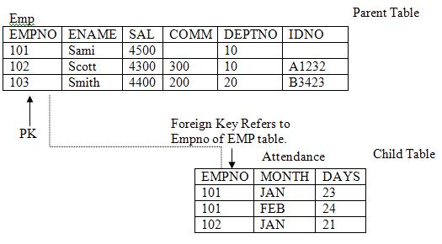
Here EMPNO in attendance table is a foreign key referring to EMPNO of EMP table.
alter table attendance add constraint empno_fk
foreign key (empno) references emp(empno);
The above command succeeds only if EMPNO column in ATTENDANCE table contains values which are existing in EMPNO column of EMP table. If any value is not existing then the above statement fails and Oracle returns an error indicating non compliant values.
Some points to remember for referential integrity
- You cannot delete a parent record if any existing child record is there. If you have to first delete the child record before deleting the parent record. In the above example you cannot delete row of employee no. 101 since it’s child exist in the ATTENDANCE table. However, you can delete the row of employee no. 103 since no child record exist for this employee in ATTENDANCE table. If you define the FOREIGN KEY with ON DELETE CASCADE option then you can delete the parent record and if any child record exist it will be automatically deleted.
To define a foreign key constraint with ON DELETE CASCADE option give the following command.
ALTER TABLE attendance ADD CONSTRAINT empno_fk
FOREIGN KEY (empno) REFERENCES emp(empno)
ON DELETE CASCADE;
From Oracle version 9i, Oracle has also given a new feature i.e. ON DELETE SET NULL . That is it sets the value for foreign key to null whenever the parent record is deleted.
To define a foreign key constraint with ON DELETE SET NULL option give the following command.
ALTER TABLE attendance ADD CONSTRAINT empno_fk
FOREIGN KEY (empno) REFERENCES emp(empno)
ON DELETE SET NULL;
- You also cannot drop the parent table without first dropping the FOREIGN KEY constraint from attendance table. However if you give CASCADE CONSTRAINTS option in DROP TABLE statement then Oracle will automatically drop the references and then drops the table.

CHECK
Use the check constraint to validate values entered into a column. For example in the above ATTENDANCE table, the DAYS column should not contain any value more than 31. For this you can define a CHECK constraint as given below
alter table attendance add constraint dayscheck
check (days <= 31);
Similarly if you want the salaries entered in to SAL column of employee table should be between 1000 and 20000 then you can define a CHECK constraint on EMP table as follows
alter table emp add constraint sal_check
check (sal between 1000 and 20000);
You can define as many check constraints on a single column as you want there is no restrictions on number of check constraints.

UNIQUE KEY
Unique Key constraint is same as primary key i.e. it does not accept duplicate values, except the following differences
- There can be only on Primary key per table. Whereas, you can have as many Unique Keys per table as you want.
- Primary key does not accept NULL values whereas, unique key columns can be left blank.
- You can also refer to Unique key from Foreign key of other tables.
On which columns you should put Unique Key Constraint ?
It depends on situations, first situation is suppose you have already defined a Primary key constraint on one column and now you have another column which also should not contain any duplicate values, Since a table can have only one primary key, you can define Unique Key constraint on these columns. Second situation is when a column should not contain any duplicate value but it should also be left blank. For example in the EMP table IDNO is a good candidate for Unique Key because all the IDNO’s are unique but some employees might not have ID Card so you want to leave this column blank.
To define a UNIQUE KEY constraint on an existing table give the following command.
alter table emp add constraint id_unique unique (idno);
Again the above command will execute successfully if IDNO column contains complying values otherwise you have to remove non complying values and then add the constraint.

How to Create and Manage Views in Oracle

Views
Views are known as logical tables. They represent the data of one of more tables. A view derives its data from the tables on which it is based. These tables are called base tables. Views can be based on actual tables or another view also.
Whatever DML operations you performed on a view they actually affect the base table of the view. You can treat views same as any other table. You can Query, Insert, Update and delete from views, just as any other table.
Views are very powerful and handy since they can be treated just like any other table but do not occupy the space of a table.
The following sections explain how to create, replace, and drop views using SQL commands.

Creating Views
Suppose we have EMP and DEPT table. To see the empno, ename, sal, deptno, department name and location we have to give a join query like this.
select e.empno,e.ename,e.sal,e.deptno,d.dname,d.loc
From emp e, dept d where e.deptno=d.deptno;
So everytime we want to see emp details and department names where they are working we have to give a long join query. Instead of giving this join query again and again, we can create a view on these table by using a CREATE VIEW command given below
create view emp_det as select e.empno,
e.ename,e.sal,e.deptno,d.dname,d.loc
from emp e, dept d where e.deptno=d.deptno;
Now to see the employee details and department names we don’t have to give a join query, we can just type the following simple query.
select * from emp_det;
This will show same result as you have type the long join query. Now you can treat this EMP_DET view same as any other table.
For example, suppose all the employee working in Department No. 10 belongs to accounts department and most of the time you deal with these people. So every time you have to give a DML or Select statement you have to give a WHERE condition like .....WHERE DEPTNO=10. To avoid this, you can create a view as given below
CREATE VIEW accounts_staff AS
SELECT Empno, Ename, Deptno
FROM Emp
WHERE Deptno = 10
WITH CHECK OPTION CONSTRAINT ica_Accounts_cnst;
Now to see the account people you don’t have to give a query with where condition you can just type the following query.
select * from accounts_staff;
select sum(sal) from accounst_staff;
select max(sal) from accounts_staff;
As you can see how views make things easier.
The query that defines the ACCOUNTS_STAFF view references only rows in department 10. Furthermore, WITH CHECK OPTION creates the view with the constraint that INSERT and UPDATE statements issued against the view are not allowed to create or result in rows that the view cannot select.
Considering the example above, the following INSERT statement successfully inserts a row into the EMP table through the ACCOUNTS_STAFF view:
INSERT INTO Accounts_staff VALUES (110, 'ASHI', 10);
However, the following INSERT statement is rolled back and returns an error because it attempts to insert a row for department number 30, which could not be selected using the ACCOUNTS_STAFF view:
INSERT INTO Accounts_staff VALUES (111, 'SAMI', 30);

Creating FORCE VIEWS
A view can be created even if the defining query of the view cannot be executed, as long as the CREATE VIEW command has no syntax errors. We call such a view a view with errors. For example, if a view refers to a non-existent table or an invalid column of an existing table, or if the owner of the view does not have the required privileges, then the view can still be created and entered into the data dictionary.
You can only create a view with errors by using the FORCE option of the CREATE VIEW command:
CREATE FORCE VIEW AS ...;
When a view is created with errors, Oracle returns a message and leaves the status of the view as INVALID. If conditions later change so that the query of an invalid view can be executed, then the view can be recompiled and become valid. Oracle dynamically compiles the invalid view if you attempt to use it.

Replacing/Altering Views
To alter the definition of a view, you must replace the view using one of the following methods:
- A view can be dropped and then re-created. When a view is dropped, all grants of corresponding view privileges are revoked from roles and users. After the view is re-created, necessary privileges must be regranted.
- A view can be replaced by redefining it with a CREATE VIEW statement that contains the OR REPLACE option. This option replaces the current definition of a view, but preserves the present security authorizations.
For example, assume that you create the ACCOUNTS_STAFF view, as given in a previous example. You also grant several object privileges to roles and other users. However, now you realize that you must redefine the ACCOUNTS_STAFF view to correct the department number specified in the WHERE clause of the defining query, because it should have been 30. To preserve the grants of object privileges that you have made, you can replace the current version of the ACCOUNTS_STAFF view with the following statement:
CREATE OR REPLACE VIEW Accounts_staff AS
SELECT Empno, Ename, Deptno
FROM Emp
WHERE Deptno = 30
WITH CHECK OPTION CONSTRAINT ica_Accounts_cnst;
Replacing a view has the following effects:
- Replacing a view replaces the view's definition in the data dictionary. All underlying objects referenced by the view are not affected.
- If previously defined but not included in the new view definition, then the constraint associated with the WITH CHECK OPTION for a view's definition is dropped.
- All views and PL/SQL program units dependent on a replaced view become invalid.
With some restrictions, rows can be inserted into, updated in, or deleted from a base table using a view. The following statement inserts a new row into the EMP table using the ACCOUNTS_STAFF view:
INSERT INTO Accounts_staff
VALUES (199, 'ABID', 30);
Restrictions on DML operations for views use the following criteria in the order listed:
- If a view is defined by a query that contains SET or DISTINCT operators, a GROUP BY clause, or a group function, then rows cannot be inserted into, updated in, or deleted from the base tables using the view.
- If a view is defined with WITH CHECK OPTION, then a row cannot be inserted into, or updated in, the base table (using the view), if the view cannot select the row from the base table.
- If a NOT NULL column that does not have a DEFAULT clause is omitted from the view, then a row cannot be inserted into the base table using the view.
- If the view was created by using an expression, such as DECODE(deptno, 10, "SALES", ...), then rows cannot be inserted into or updated in the base table using the view.
The constraint created by WITH CHECK OPTION of the ACCOUNTS_STAFF view only allows rows that have a department number of 10 to be inserted into, or updated in, the EMP table. Alternatively, assume that the ACCOUNTS_STAFF view is defined by the following statement (that is, excluding the DEPTNO column):
CREATE VIEW Accounts_staff AS
SELECT Empno, Ename
FROM Emp
WHERE Deptno = 10
WITH CHECK OPTION CONSTRAINT ica_Accounts_cnst;
Considering this view definition, you can update the EMPNO or ENAME fields of existing records, but you cannot insert rows into the EMP table through the ACCOUNTS_STAFF view because the view does not let you alter the DEPTNO field. If you had defined a DEFAULT value of 10 on the DEPTNO field, then you could perform inserts.
If you don’t want any DML operations to be performed on views, create them WITH READ ONLY option. Then no DML operations are allowed on views.

Referencing Invalid Views
When a user attempts to reference an invalid view, Oracle returns an error message to the user:
ORA-04063: view 'view_name' has errors
This error message is returned when a view exists but is unusable due to errors in its query (whether it had errors when originally created or it was created successfully but became unusable later because underlying objects were altered or dropped).

Dropping Views
Use the SQL command DROP VIEW to drop a view. For example:
DROP VIEW Accounts_staff;

Modifying a Join View
Oracle allows you, with some restrictions, to modify views that involve joins. Consider the following simple view:
CREATE VIEW Emp_view AS
SELECT Ename, Empno, deptno FROM Emp;
This view does not involve a join operation. If you issue the SQL statement:
UPDATE Emp_view SET Ename = 'SHAHRYAR' WHERE Empno = 109;
then the EMP base table that underlies the view changes, and employee 109's name changes from ASHI to SHAHRYAR in the EMP table.
However, if you create a view that involves a join operation, such as:
CREATE VIEW Emp_dept_view AS
SELECT e.Empno, e.Ename, e.Deptno, e.Sal, d.Dname, d.Loc
FROM Emp e, Dept d /* JOIN operation */
WHERE e.Deptno = d.Deptno
AND d.Loc IN ('HYD', 'BOM', 'DEL');
then there are restrictions on modifying either the EMP or the DEPT base table through this view.
A modifiable join view is a view that contains more than one table in the top-level FROM clause of the SELECT statement, and that does not contain any of the following:
- DISTINCT operator
- Aggregate functions: AVG, COUNT, GLB, MAX, MIN, STDDEV, SUM, or VARIANCE
- Set operations: UNION, UNION ALL, INTERSECT, MINUS
- GROUP BY or HAVING clauses
- START WITH or CONNECT BY clauses
- ROWNUM pseudocolumn
Any UPDATE, INSERT, or DELETE statement on a join view can modify only one underlying base table.
The following example shows an UPDATE statement that successfully modifies the EMP_DEPT_VIEW view:
UPDATE Emp_dept_view
SET Sal = Sal * 1.10
WHERE Deptno = 10;
The following UPDATE statement would be disallowed on the EMP_DEPT_VIEW view:
UPDATE Emp_dept_view
SET Loc = 'BOM'
WHERE Ename = 'SAMI';
This statement fails with an ORA-01779 error ("cannot modify a column which maps to a non key-preserved table"), because it attempts to modify the underlying DEPT table, and the DEPT table is not key preserved in the EMP_DEPT view.
In general, all modifiable columns of a join view must map to columns of a key-preserved table. If the view is defined using the WITH CHECK OPTION clause, then all join columns and all columns of repeated tables are not modifiable.
So, for example, if the EMP_DEPT view were defined using WITH CHECK OPTION, then the following UPDATE statement would fail:
UPDATE Emp_dept_view
SET Deptno = 10
WHERE Ename = 'SAMI';
The statement fails because it is trying to update a join column.

Deleting from a Join View
You can delete from a join view provided there is one and only one key-preserved table in the join.
The following DELETE statement works on the EMP_DEPT view:
DELETE FROM Emp_dept_view
WHERE Ename = 'SMITH';
This DELETE statement on the EMP_DEPT view is legal because it can be translated to a DELETE operation on the base EMP table, and because the EMP table is the only key-preserved table in the join.
In the following view, a DELETE operation cannot be performed on the view because both E1 and E2 are key-preserved tables:
CREATE VIEW emp_emp AS
SELECT e1.Ename, e2.Empno, e1.Deptno
FROM Emp e1, Emp e2
WHERE e1.Empno = e2.Empno;
If a view is defined using the WITH CHECK OPTION clause and the key-preserved table is repeated, then rows cannot be deleted from such a view. For example:
CREATE VIEW Emp_mgr AS
SELECT e1.Ename, e2.Ename Mname
FROM Emp e1, Emp e2
WHERE e1.mgr = e2.Empno
WITH CHECK OPTION;
No deletion can be performed on this view because the view involves a self-join of the table that is key preserved.

Inserting into a Join View
The following INSERT statement on the EMP_DEPT view succeeds, because only one key-preserved base table is being modified (EMP), and 40 is a valid DEPTNO in the DEPT table (thus satisfying the FOREIGN KEY integrity constraint on the EMP table).
INSERT INTO Emp_dept (Ename, Empno, Deptno)
VALUES ('ASHU', 119, 40);
The following INSERT statement fails for the same reason: This UPDATE on the base EMP table would fail: the FOREIGN KEY integrity constraint on the EMP table is violated.
INSERT INTO Emp_dept (Ename, Empno, Deptno)
VALUES ('ASHU', 110, 77);
The following INSERT statement fails with an ORA-01776 error ("cannot modify more than one base table through a view").
INSERT INTO Emp_dept (Ename, Empno, Deptno)
VALUES (110, 'TANNU’, 'BOMBAY');
An INSERT cannot, implicitly or explicitly, refer to columns of a non-key-preserved table. If the join view is defined using the WITH CHECK OPTION clause, then you cannot perform an INSERT to it.

Listing Information about VIEWS.
To see how many views are there in your schema. Give the following query.
select * from user_views;
To see which columns are updatable in join views.

Data Dictionaries which shows which columns are updatable.
View Name | Description
USER_UPDATABLE_COLUMNS | Shows all columns in all tables and views in the user's schema that are modifiable
DBA_UPDATABLE_COLUMNS | Shows all columns in all tables and views in the DBA schema that are modifiable
ALL_UPDATABLE_VIEWS | Shows all columns in all tables and views that are modifiable
If you are in doubt whether a view is modifiable, then you can SELECT from the view USER_UPDATABLE_COLUMNS to see if it is. For example:
SELECT * FROM USER_UPDATABLE_COLUMNS WHERE TABLE_NAME = 'EMP_DEPT_VIEW';
This might return:
OWNER TABLE_NAME COLUMN_NAM UPD
---------- ---------- ---------- ---
SCOTT EMP_DEPT EMPNO NO
SCOTT EMP_DEPT ENAME NO
SCOTT EMP_DEPT DEPTNO NO
SCOTT EMP_DEPT DNAME NO
SCOTT EMP_DEPT LOC NO
5 rows selected.
How to Create and Manage Partition Tables in Oracle

Table Partitioning
Now a days enterprises run databases of hundred of Gigabytes in size. These databases are known as Very Large Databases (VLDB). From Oracle Ver. 8.0 Oracle has provided the feature of table partitioning i.e. you can partition a table according to some criteria . For example you have a SALES table with the following structure
Suppose this table contains millions of records, but all the records belong to four years only i.e. 1991, 1992, 1993
and 1994. And most of the time you are concerned about only one year i.e. you give queries like the following
select sum(amt) from sales where year=1991;
select product,sum(amt) from sales where year=1992
Group by product;
Now whenever you give queries like this Oracle will search the whole table. If you partition this table according to
year, then the performance is improve since oracle will scan only a single partition instead of whole table.

CREATING PARTITION TABLES
To create a partition table give the following statement
create table sales (year number(4),
product varchar2(10),
amt number(10,2))
partition by range (year)
partition p1 values less than (1992) tablespace u1,
partition p2 values less than (1993) tablespace u2,
partition p3 values less than (1994) tablespace u3,
partition p4 values less than (1995) tablespace u4,
partition p5 values less than (MAXVALUE) tablespace u5;
In the above example sales table is created with 5 partitions. Partition p1 will contain rows of year 1991 and
it will be stored in tablespace u1. Partition p2 will contain rows of year 1992 and it will be stored in tablespace u2.
Similarly p3 and p4.
In the above example if you don’t specify the partition p4 with values less than MAVALUE, then you will not be
able to insert any row with year above 1994.
Although not required, you can place partitions in different tablespaces. If you place partitions in different tablespaces
then you can isolate problems due to failures as only a particular partition will not be available and rest of the
partitions will still be available.
The above example the table is partition by range.
In Oracle you can partition a table by
- Range Partitioning
- Hash Partitioning
- List Partitioning
- Composite Partitioning

Range Partitioning
This type of partitioning is useful when dealing with data that has logical ranges into which it can be distributed;
for example, value of year. Performance is best when the data evenly distributes across the range

Hash partitioning
Use hash partitioning if your data does not easily lend itself to range partitioning, but you would like to partition for
performance and manageability reasons. Hash partitioning provides a method of evenly distributing data across a
specified number of partitions. Rows are mapped into partitions based on a hash value of the partitioning key
The following example shows how to create a hash partition table.
The following example creates a hash-partitioned table. The partitioning column is partno, four partitions are created
and assigned system generated names, and they are placed in four named tablespaces (tab1,tab2, ...).
CREATE TABLE products
(partno NUMBER,
description VARCHAR2 (60))
PARTITION BY HASH (partno)
PARTITIONS 4
STORE IN (tab1, tab2, tab3, tab4);

List Partitioning
Use list partitioning when you require explicit control over how rows map to partitions. You can specify a list of discrete
values for the partitioning column in the description for each partition. This is different from range partitioning, where a
range of values is associated with a partition, and from hash partitioning, where the user has no control of the row to
partition mapping.

List partitioning allows unordered and unrelated sets of data to be grouped and organized together very naturally
The following example creates a table with list partitioning
create table customers (custcode number(5),
Name varchar2(20),
Addr varchar2(10,2),
City varchar2(20),
Bal number(10,2))
Partition by list (city),
Partition north_India values (‘DELHI’,’CHANDIGARH’),
Partition east_India values (‘KOLKOTA’,’PATNA’),
Partition south_India values (‘HYDERABAD’,’BANGALORE’,’CHENNAI’),
Partition west India values (‘BOMBAY’,’GOA’);
If a row is inserted in the above table then oracle maps the value of city column and whichever partition list matches the
city column the row is stored in that partition.

COMPOSITE PARTITONING
Composite partitioning partitions data using the range method, and within each partition, subpartitions it using
the hash method. Composite partitions are ideal for both historical data and striping, and provide improved
manageability of range partitioning and data placement, as well as the parallelism advantages of hash partitioning.
When creating composite partitions, you specify the following:
- Partitioning method: range
- Partitioning column(s)
- Partition descriptions identifying partition bounds
- Subpartitioning method: hash
- Subpartitioning column(s)
- Number of subpartitions for each partition or descriptions of subpartitions
The following statement creates a composite-partitioned table. In this example, three range partitions are created, each
containing eight subpartitions. Because the subpartitions are not named, system generated names are assigned, but the
STORE IN clause distributes them across the 4 specified tablespaces (tab1, ...,tab4).
CREATE TABLE PRODUCTS (partno NUMBER,
description VARCHAR(32),
costprice NUMBER)
PARTITION BY RANGE (partno)
SUBPARTITION BY HASH(description)
SUBPARTITIONS 8 STORE IN (tab1, tab2, tab3, tab4)
(PARTITION p1 VALUES LESS THAN (100),
PARTITION p2 VALUES LESS THAN (200),
PARTITION p3 VALUES LESS THAN (MAXVALUE));

LISTING INFORMATION ABOUT PARTITION TABLES
To see how many partitioned tables are there in your schema give the following statement
select * from user_part_tables;
To see on partition level partitioning information
select * from user_tab_partitions;

